Evidence Preservation and Analysis Report
Objective
The objective of this exercise was to understand the importance of digital evidence preservation during cybersecurity investigations. The activity focused on collecting volatile system data, preserving forensic evidence, generating cryptographic hashes, and maintaining a proper chain of custody to ensure evidence integrity throughout the investigation process.
Tools Used
- Velociraptor
- FTK Imager
- SHA256 Hashing Utility
- Microsoft Excel
- Microsoft Word
Introduction
Evidence preservation is a critical component of digital forensics and incident response. Proper evidence handling ensures that collected artifacts remain accurate, reliable, and legally defensible.
During a security incident, investigators must collect volatile and non-volatile data while maintaining the integrity of all evidence. Any modification or improper handling can compromise the investigation and reduce the reliability of findings.
This exercise simulated the collection and preservation of digital evidence from a potentially compromised system.
Volatile Data Collection
Volatile data refers to information that may be lost when a system is powered off or restarted. Examples include active network connections, running processes, and memory contents.
Using Velociraptor, network connection information was collected from the target system.
Sample Network Connections
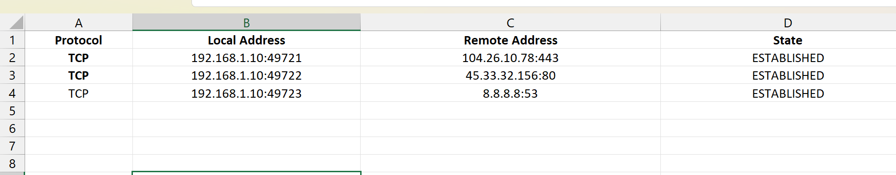The collected network data provided visibility into active communications occurring during the investigation.
Memory Acquisition
A memory acquisition process was performed to preserve the contents of system memory for future forensic analysis.
The memory dump was collected from the target system and stored securely within the evidence repository.
Memory Evidence Details

Memory acquisition preserves critical forensic artifacts including:
- Running processes
- Active user sessions
- Network connections
- Encryption keys
- Malware artifacts
Hash Verification
To verify evidence integrity, a SHA256 cryptographic hash was generated for the collected memory image.
Hash Information
Evidence Item | Hash Algorithm
Memory Dump | SHA256
Sample SHA256 Hash
7f4c9d7e2a1baf34c6d8e9f1a2b3c4d5e6f7081928374655647382910abcdef
The generated hash serves as a digital fingerprint for the evidence. Any modification to the file would result in a different hash value, indicating potential tampering.
Evidence Log
All collected evidence was documented in an evidence log to support accountability and tracking.

Evidence Inventory
Maintaining an evidence inventory ensures that all collected artifacts can be identified, tracked, and verified throughout the investigation.
Chain of Custody
A chain of custody record was maintained to document every action performed on the evidence.
Chain of Custody Activities
The chain of custody ensures transparency and demonstrates that evidence remained under controlled handling procedures.
Findings
The exercise successfully demonstrated the collection and preservation of digital evidence using standard forensic procedures.
Key findings included:
- Successful collection of volatile network data.
- Memory image acquired without errors.
- SHA256 hash generated for integrity verification.
- Evidence inventory maintained.
- Chain of custody properly documented.
These procedures ensured that all evidence remained reliable and suitable for future forensic analysis.
Results
The evidence preservation process was completed successfully. All collected artifacts were documented, hashed, and stored according to accepted forensic practices.
The exercise demonstrated how SOC analysts and incident responders preserve critical evidence while maintaining integrity and accountability throughout an investigation.

Conclusion
Evidence preservation is an essential component of incident response and digital forensics. Proper collection, documentation, hashing, and chain-of-custody procedures help ensure that evidence remains trustworthy and usable for investigative and legal purposes.
This exercise successfully demonstrated the complete evidence preservation workflow, including volatile data collection, memory acquisition, hash verification, and evidence tracking. All objectives were achieved, and the collected evidence remained intact throughout the process.

